



 S.K.P ENGINEERING COLLEGE

Approved by AICTE & Affiliated to Anna University

NH 66, Somasipadi Post,Chinnakangiyanur, Tiruvannamalai,

Tamil Nadu-606611

**DEPARTMENT OF COMPUTER SCIENCE AND**

**ENGINEERING**

BACHELOR OF ENGINEERING 2024-2025

FIFTH SEMESTER

**PROJECT TITLE: TRIP ADVISOR E-MANAGEMENT**

**Project Created by:** Deepan.R , Dhanush.J , Dharshan.G, Dinesh.M

**Project Reviewed by:** Mr.Nasrudeen sha (AP/CSE)

**College Code:** 5122

**Team ID** : NM2024TMID03197





 S.K.P ENGINEERING COLLEGE

Approved by AICTE & Affiliated to Anna University

**DEPARTMENT OF COMPUTER SCIENCE AND**

**ENGINEERING**

Certified that this is a bonafide record of work done by

Name : Deepan.R , Dhanush.J , Dharshan.G, Dinesh.M

University Reg No :

Year / Semester : 3 / 5

Branch : CSE

Year : 2024-2025

**Staff-in-Charge Head of the Department**

Submitted for the

Practical Examination held on

**Internal Examiner External Examiner**

**Abstract**

The TripAdvisor E-Management app with the salesforce works with your all-in-one travel companion, empowering you to plan, book, and make the most of the trips. Discover millions of reviews and insights shared by fellow travelers, helping you make informed decisions for every aspect of your journey. Whether you're seeking the perfect hotel, top-rated restaurants, must-visit attractions, or the best travel deals, TripAdvisor has you covered

**OBJECTIVE**

Primary Goal of the Project to Customization  process for the proper flow of the business if TripAdvisor where they can easily access the Hotel requirement then food options and also the ease for the customers with the preferable discount with there Amount limits this process helps to save time from multiple manual processes.

**SCOPE:**

This project aims to enhance travel management and customer experience through the following key activities:

1. **Review Management**: Collect and analyze customer reviews, and automate responses to feedback.
2. **Booking Management**: Automate booking confirmations, updates, and cancellations.
3. **Customer Relationship Management (CRM)**: Centralize customer interactions and personalize communication.
4. **Task Coordination**: Assign and track tasks related to bookings and customer support.
5. **Analytics and Reporting**: Generate reports on customer satisfaction and booking trends.
6. **Integration with External System**

**INTRODUCTION TO SALESFORCE**

Salesforce is a leading cloud-based Customer Relationship Management (CRM) platform that enables organizations to streamline their business processes and enhance customer interactions. Established in 1999, Salesforce offers a suite of applications for sales, customer service, marketing, and more, designed to help businesses manage relationships with customers, prospects, and partners.

**Key Features of Salesforce:**

1. **Customizable CRM:** Salesforce provides a highly customizable platform that can be tailored to meet the specific needs of any business, regardless of industry.
2. **Cloud-Based:** As a cloud-based service, Salesforce allows users to access their data from anywhere, on any device, ensuring flexibility and mobility.
3. **Integration Capabilities:** Salesforce can be integrated with a wide variety of other systems and applications, allowing for seamless data flow across different platforms.
4. **Automation:** The platform supports advanced automation features, such as workflow rules, process builder, and Salesforce Flow, to automate repetitive tasks and improve efficiency.
5. **Analytics and Reporting:** Salesforce offers robust analytics and reporting tools that provide insights into business performance and help make data-driven decisions.
6. **AppExchange:** This marketplace offers a wide range of third-party applications and integrations that can extend Salesforce’s functionality.

**WHY SALESFORCE FOR THIS APPLICATION?**

1. **Integrated Platform**
   * Manage reviews, bookings, and customer interactions in one place.
2. **Scalability:**
   * Scale with your business as it grows.
3. **Customization:**
   * Tailor Salesforce to meet specific project needs with custom objects, fields, and workflows.
4. **Automation:**
   * Utilize Salesforce Einstein for AI-driven insights and predictive analytics.
5. **Analytics and AI:**
   * Maintain accurate records for audit and compliance purposes.
   * Ensure accountability through detailed documentation of all activities and processes.

**Key Components**

1. **Custom Objects and Fields:**
   * Create custom objects for Reviews, Bookings, and Customer Interactions.
   * Define necessary fields like review content, booking dates, customer details.
2. **Automation:**
   * Set up workflows and process builders to automate responses, reminders, and status updates.
3. **Reports and Dashboards:**
   * Create custom reports for tracking key metrics.
   * Build dashboards for visualizing data and monitoring performance.
4. **Integration:**
   * Integrate Salesforce with other systems (e.g., TripAdvisor API) to pull in reviews and booking data.

**IMPLEMENTATION**

The project will be implemented in Salesforce, with the following steps:

**Salesforce Developer Account Creation:**

### Creating Developer Account:

Creating a developer org in salesforce.

1. Go to <https://developer.salesforce.com/signup>
2. On the sign up form, enter the following details :[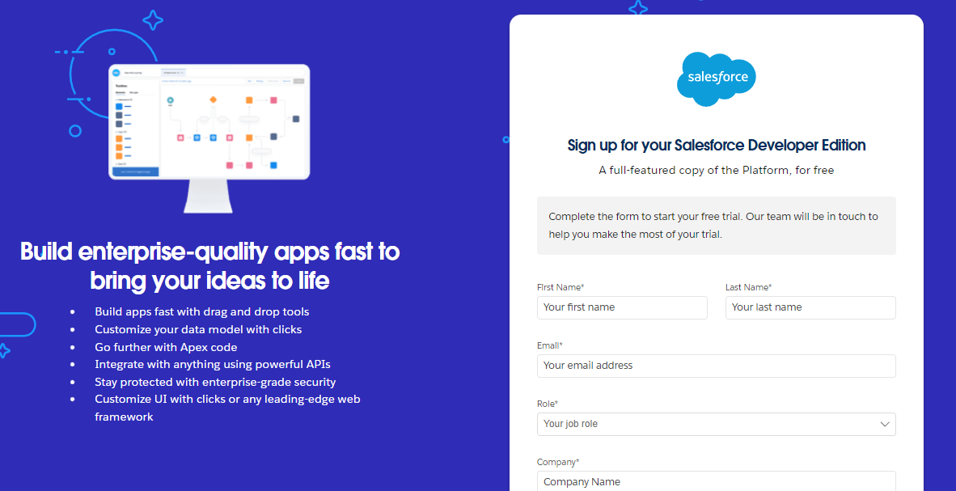](https://developers.salesforce.com/Signup*)
   1. First name & Last name
   2. Email
   3. Role : Developer
   4. Company : College or Company Name
   5. County : India
   6. Postal Code : pin code
   7. Username : should be a combination of your name and company

This need not be an actual email id, you can give anything in the format :

username@organization.com

Click on sign me up after filling these.

**Account Activation**

1. Go to the inbox of the email that you used while signing up. Click on the verify account to activate your account. The email may take 5-10mins.

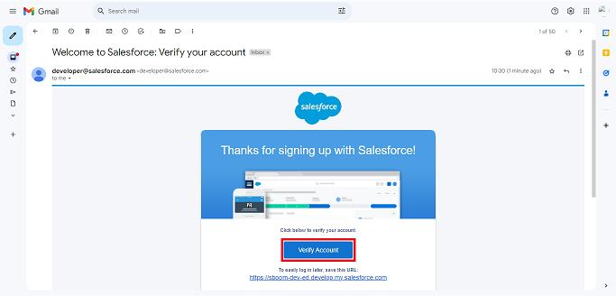

1. 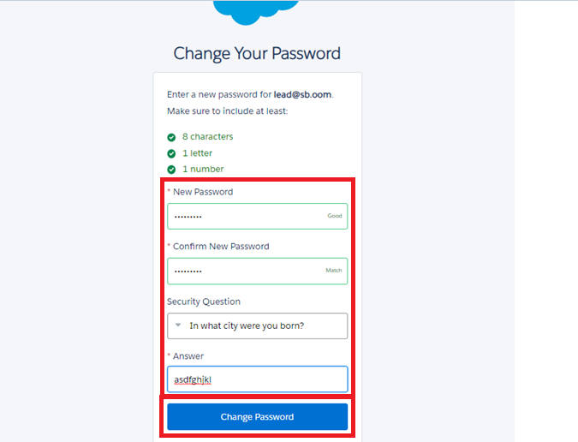Click on Verify Account
2. Give a password and answer a security question and click on change password.

1. Give a password and answer a security question and click on change password.
2. Then you will redirect to your salesforce setup page.

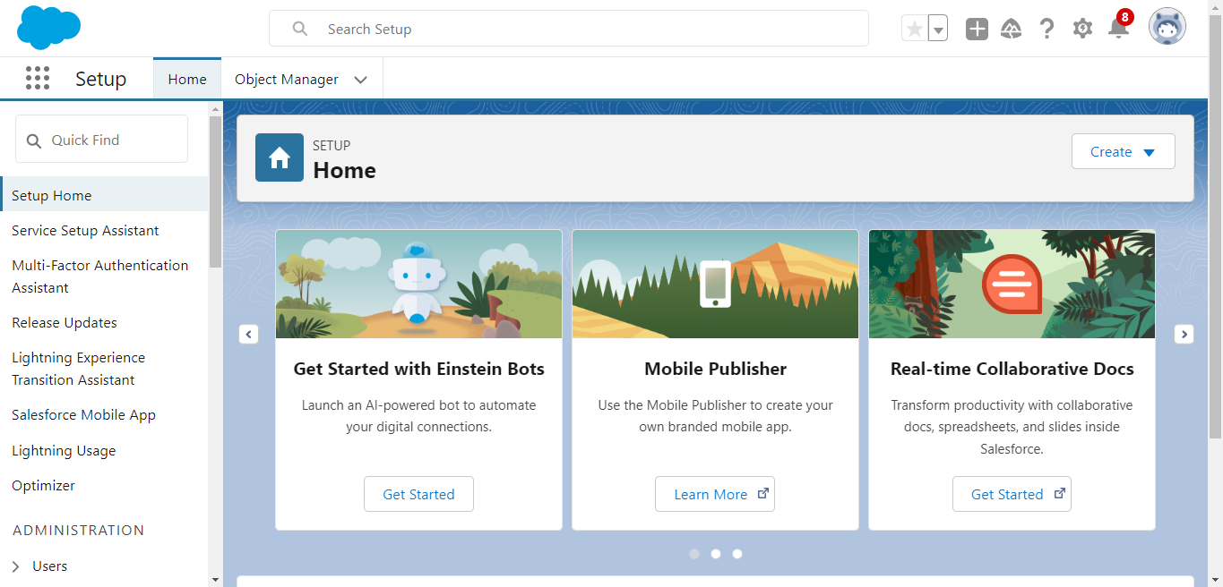

**CREATION OF OBJECTS:**

**Create Hotel Object:**

To create an object:

1. From the setup page >> Click on Object Manager >> Click on Create >>Click on Custom Object.
2. Enter the label name >> Hotel
3. Plural label name >> Hotels
4. Enter Record Name Label and Format

* Record Name >> Hotel Name
* Data Type >> Text

1. Click on Allow reports.
2. Allow search >> Save.

### Create Food Option Object

To create an object:

1. From the setup page >> Click on Object Manager >> Click on Create >>Click on Custom Object.
2. Enter the label name >> Food Option
3. Plural label name >> Food Options
4. Enter Record Name Label and Format

* Record Name >> Food Options Name
* Data Type >> Auto Number
* Format >> FO-{0000}

1. Click on Allow reports.
2. Allow search >> Save.

### Create Flight Object

To create an object:

1. From the setup page >> Click on Object Manager >> Click on Create >>Click on Custom Object.
2. Enter the label name >> Flight
3. Plural label name >> Flights
4. Enter Record Name Label and Format

* Record Name >> Flight Name
* Data Type >> Auto Number
* Format >> FL-{0000}

1. Click on Allow reports.
2. Allow search >> Save.

### Create Customer Object

To create an object:

1. From the setup page >> Click on Object Manager>> Click on Create >> Click on Custom Object.
2. Enter the label name>> Customer
3. Plural label name>> Customers
4. Enter Record Name Label and Format

* Record Name >> Customer Name
* Data Type >> Text

1. Click on Allow reports.
2. Allow search >> Save.

**Creation Fields For Hotel Objects**

1. Go to setup >> click on Object Manager >> type object name(Hotel) in the search  bar >> click on the object.
2. Now click on “Fields & Relationships” >> New
3. Select Number and Date Data Type
4. Field Name : TotalFoodOptions and Date
5. Field label : Auto generated
6. Next >> Next >> Save.

**Creation Fields For Food Option Objects**

1. Go to setup >> click on Object Manager >> type object name(Food Option) in the search  bar >> click on the object.
2. Now click on “Fields & Relationships” >> New
3. Select Text, Lookup and Currency Data Type
4. Field Name : Name, Hotel, and Food Amount
5. Field label : Auto generated
6. Next >> Next >> Save.

**Creation Fields For Customer Objects**

1. Go to setup >> click on Object Manager >> type object name(Customer) in the search  bar >> click on the object.
2. Now click on “Fields & Relationships” >> New
3. Select Text, Formula and Percentage
4. Field Name : Customer Name, Discount Amount and Discount Percent
5. Field label : Auto generated
6. Next >> Next >> Save.

**Creation Fields For Flight Objects**

1. Go to setup >> click on Object Manager >> type object name(Flight) in the search  bar >> click on the object.
2. Now click on “Fields & Relationships” >> New
3. Select Text and Date/Time Data Type
4. Field Name : Name and DepartureDateTime
5. Field label : Auto generated
6. Next >> Next >> Save.

**FLOWS:**

### Create Flow To Get Record for Amount Discount

1. Go to setup >> type Flow in quick find box >> Click on the Flow and Select the New Flow.
2. Create Variables
3. Variable > Api name > foId > text > Available for Input
4. Variable > Api name > csId > text > Available for Input
5. Variable >Api name > discount > Number
6. Label Name: Get Food Options
7. Object >> Food Option

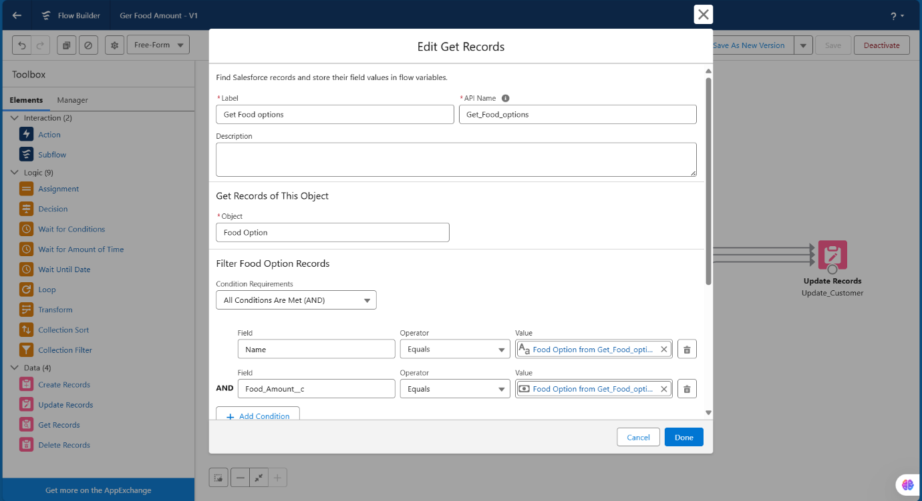

1. Next
2. Create Decision Element and 2 Outcomes
3. * Full Discount
4. * Partial Discount
5. * No Discount

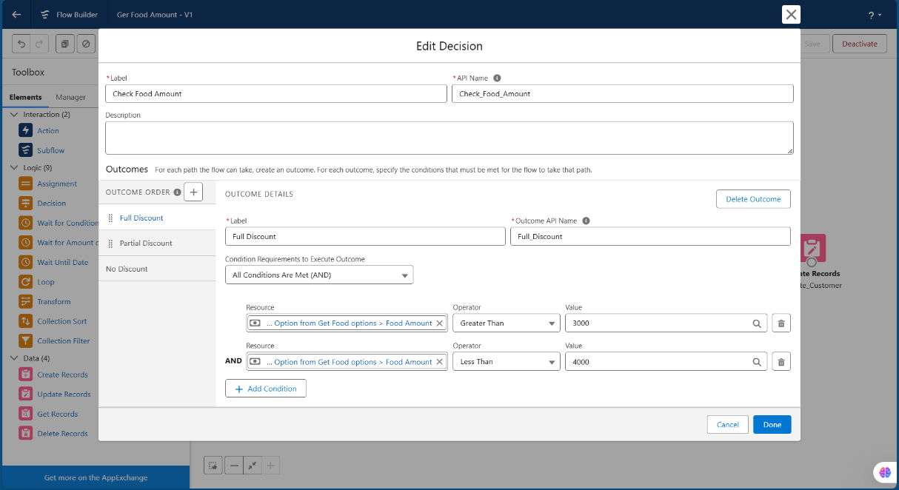

1. Create Assignment for Each Decision
2. Assign Discount Percentage for Each Decision
3. Full Discount (Variable = Discount, Operator = Equals, Value = 20 )
4. Partial Discount (Variable = Discount, Operator = Equals, Value = 10 )
5. Full Discount (Variable = Discount, Operator = Equals, Value = 0 )
6. Now Getting Update Record
7. Select = Specify Condition to identify Record and set fields Individually
8. Object = Customer
9. Fields = id, Operator = Equals, Value = csid

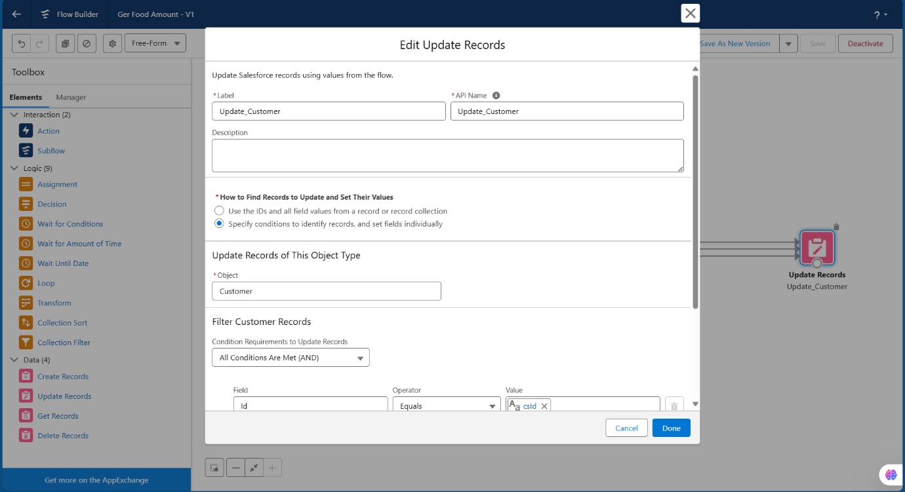

1. Save
2. Label = Get Food Amount
3. Activate

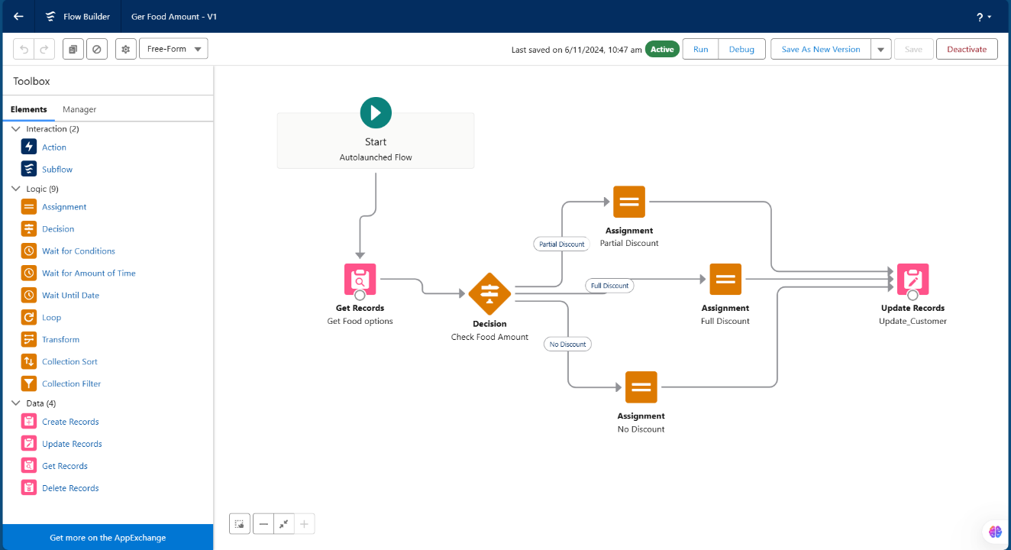

**TRIGGER:**

### Create A Trigger

1. Log into the trailhead account, navigate to the gear icon in the top right corner.
2. Click on developer console and you will be navigated to a new console window.
3. Click on the File menu in the toolbar, and click on new >> Trigger.
4. Enter the trigger name and the object to be triggered.Enter Name : FoodOptionTrigger Object: Food Option.
5. Click on Submit.

**TRIGGER CODE:**

**Code:**

trigger FoodOptionTrigger on Food_Option__c (after insert, after update, after delete) {

    If(trigger.isInsert && trigger.isAfter){

     FoodOptionTriggerHandler.updateHotelInformation(trigger.new);

    }

}

**Apex Class Code:**

public class FoodOptionTriggerHandler {

public static void updateHotelInformation(List<Food_Option__c> newFoodOptions, List<Food_Option__c> oldFoodOptions, TriggerOperation operation) {

Set<Id> hotelIdsToUpdate = new Set<Id>();

for (Food_Option__c foodOption : newFoodOptions) {

hotelIdsToUpdate.add(foodOption.Hotel__c);

}

List<Hotel__c> hotelsToUpdate = [SELECT Id, Name, TotalFoodOptions__c FROM Hotel__c WHERE Id IN :hotelIdsToUpdate];

for (Hotel__c hotel : hotelsToUpdate) {

Integer totalFoodOptions = [SELECT COUNT() FROM Food_Option__c WHERE Hotel__c = :hotel.Id];

hotel.TotalFoodOptions__c = totalFoodOptions;

}

update hotelsToUpdate;

}

}

**Apex Schedule Class Code:**

public class FlightReminderScheduledJob implements Schedulable {

public void execute(SchedulableContext sc) {

sendFlightReminders();

}

private void sendFlightReminders() {

// Query for flights departing within the next 24 hours

List<Flight__c> upcomingFlights = [SELECT Id, Name, DepartureDateTime__c FROM Flight__c

WHERE DepartureDateTime__c >= :DateTime.now()

AND DepartureDateTime__c <= :DateTime.now().addDays(1)];

for (Flight__c flight : upcomingFlights) {

// Customize the logic to send reminder emails

// For this example, we'll print a log message; replace this with your email sending logic.

System.debug('Sending reminder email for Flight ' + flight.Name + ' to ' + flight.ContactEmail__c);

// Example: Send email using Messaging.SingleEmailMessage

Messaging.SingleEmailMessage email = new Messaging.SingleEmailMessage();

email.setToAddresses(new List<String>{ flight.ContactEmail__c });

email.setSubject('Flight Reminder: ' + flight.Name);

email.setPlainTextBody('This is a reminder for your upcoming flight ' + flight.Name +

' departing on ' + flight.DepartureDateTime__c);

Messaging.sendEmail(new List<Messaging.SingleEmailMessage>{ email });

}

}

}

**TripAdivosr E-Management App**

**1.Dashboard**

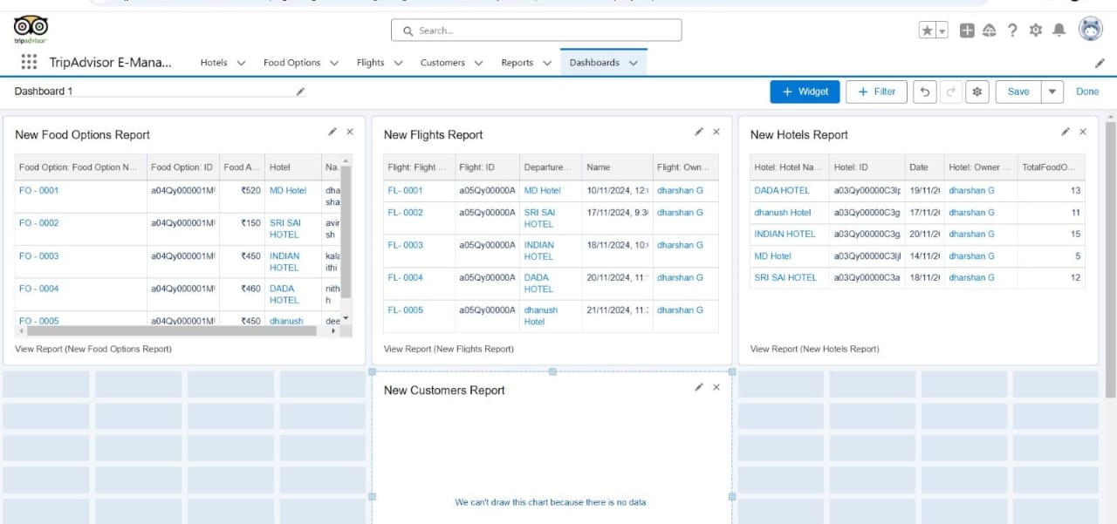

**2.Report**

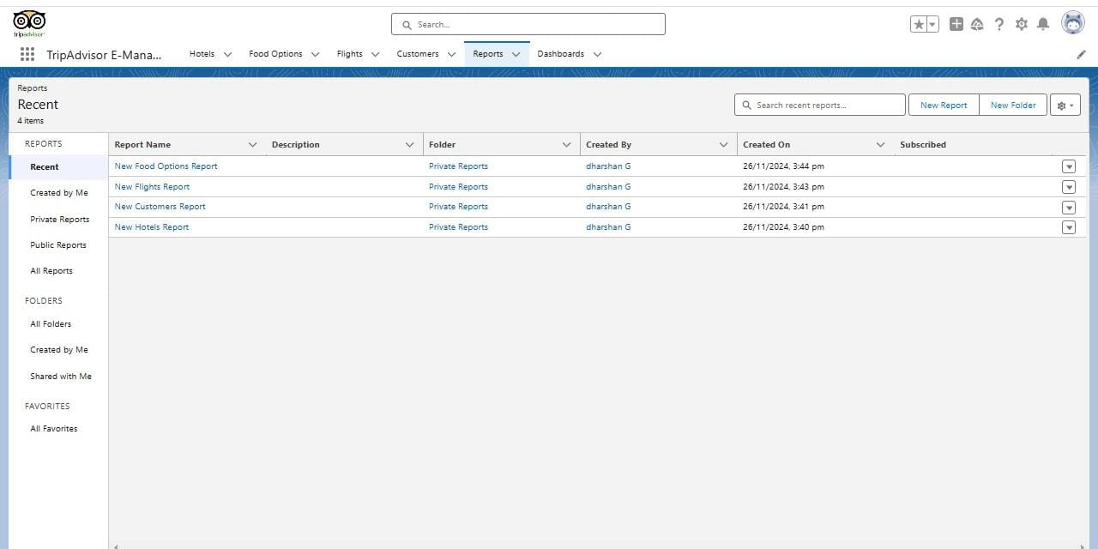

**3.Customer**

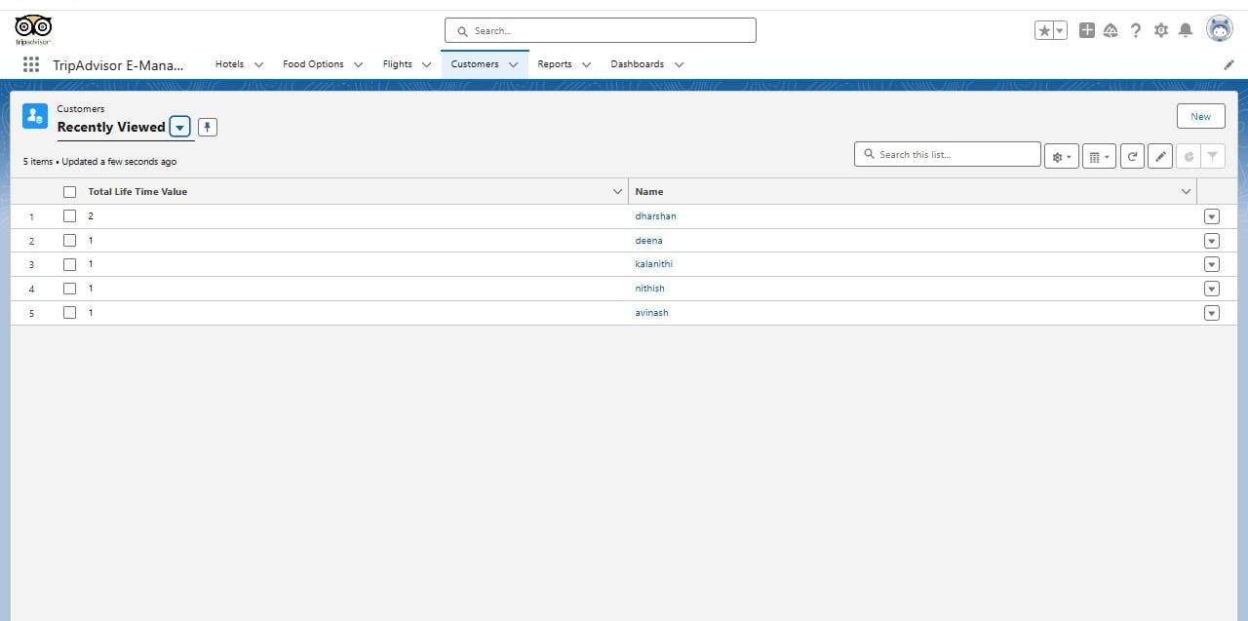

**4.Flights**

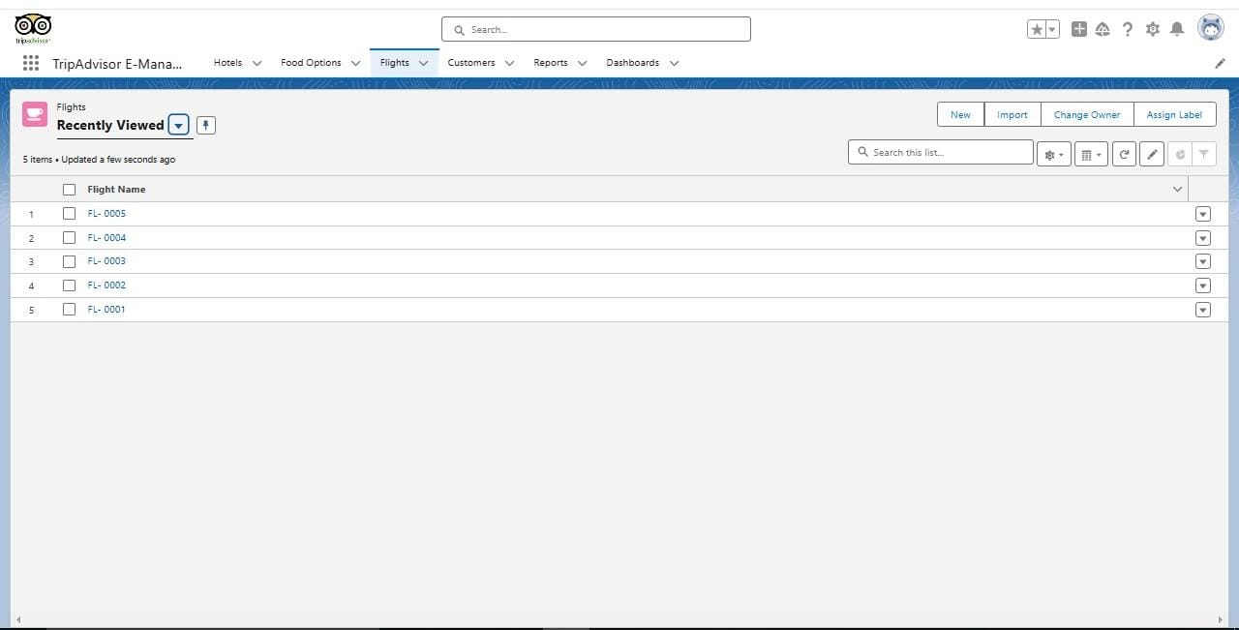

**5.Food Options**

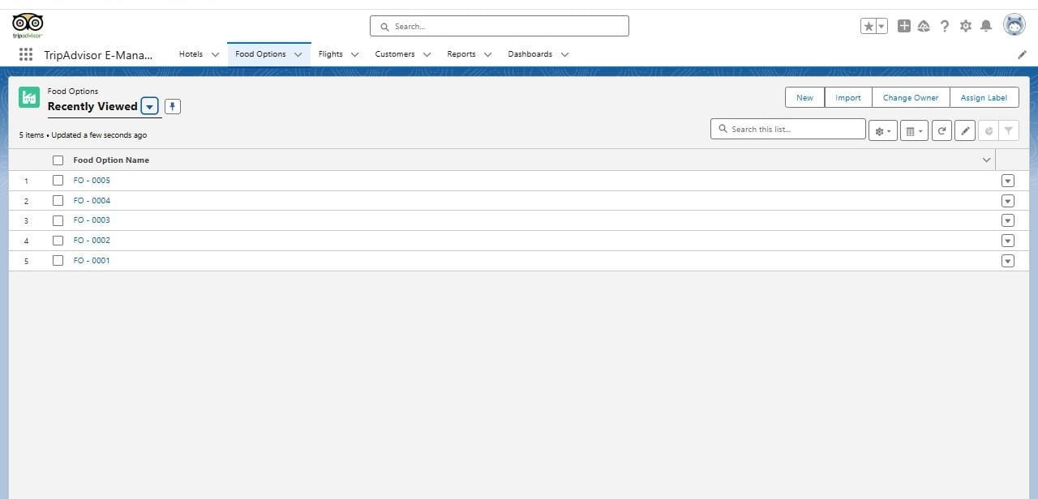

**6.Hotels**

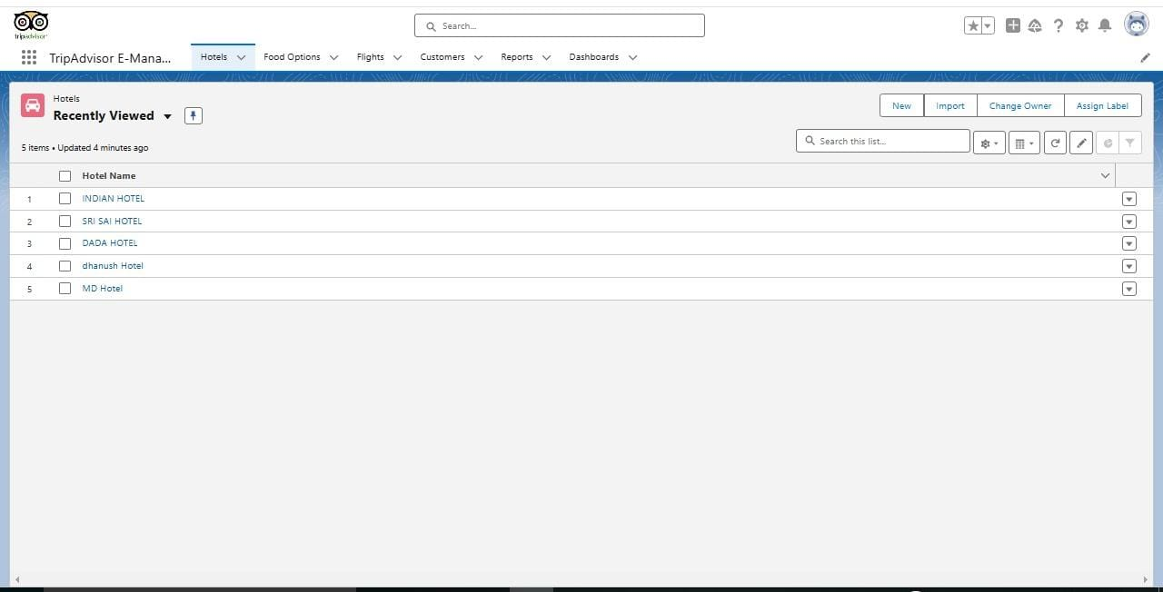

**7.Email Notification for Flight Departure Time**

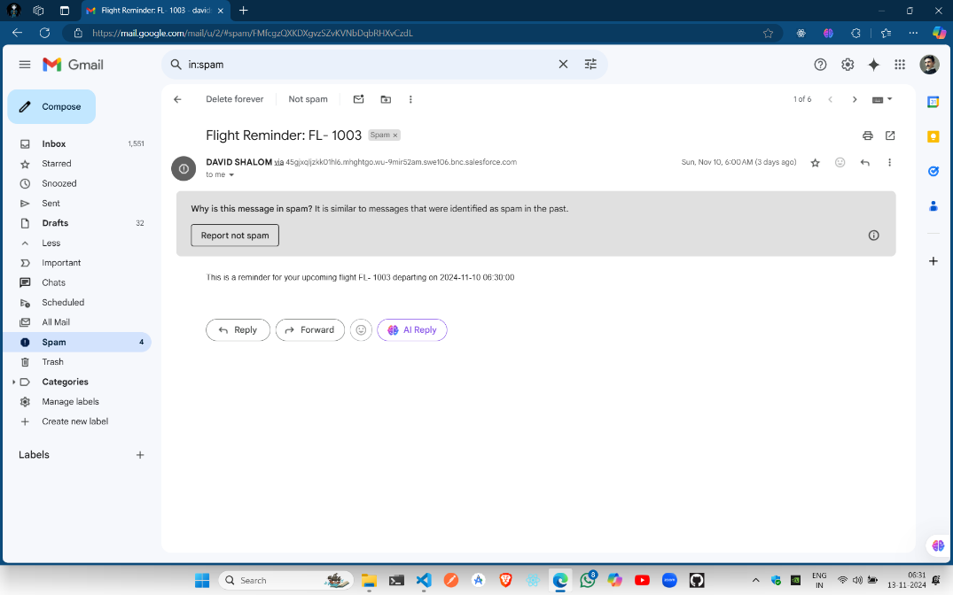

**Impact**

The TripAdvisor E-Management project aims to significantly enhance customer satisfaction and operational efficiency by leveraging Salesforce’s robust capabilities. By automating review and booking management, the project ensures timely responses and personalized interactions, leading to happier customers. The integration of data-driven insights helps refine services and improve the overall customer experience. Salesforce’s scalability supports the system's growth, accommodating increasing volumes of reviews and bookings. Additionally, efficient task coordination and resource utilization lead to cost savings and improved productivity. Overall, this project streamlines travel management processes and optimizes resource use, providing long-term benefits for both the business and its customers.

**Conclusion:**

The TripAdvisor E-Management project has successfully transformed travel management by integrating and automating key processes using Salesforce. By streamlining review management, automating booking confirmations, and centralizing customer interactions, the project has significantly enhanced operational efficiency and customer satisfaction. The data-driven insights gained through robust analytics and reporting have empowered informed decision-making, leading to continuous service improvement. Additionally, the scalability and flexibility of Salesforce ensure that the system can grow with the business, accommodating increasing volumes of data and interactions. This comprehensive approach not only optimizes resource utilization but also fosters better customer relationships, ultimately contributing to the project's success in providing a superior travel experience and driving long-term business growth.